Overview: K12 SWP Dashboard includes the following data
- Aggregated student level data for 9th - 12th graders
- Data reflects LEAs awarded K12 SWP funding in Rounds 1, 2, or 3
- Data reflects those who successfully uploaded their CALPADS files to Cal-Pass Plus
- Displays data for institutions mapped to the funded LEAs
- Data can be categorized at the institution, LEA, county, region, and statewide levels

Dashboard Utilization: (Ex. LEA or Institution: Ocean Unified)
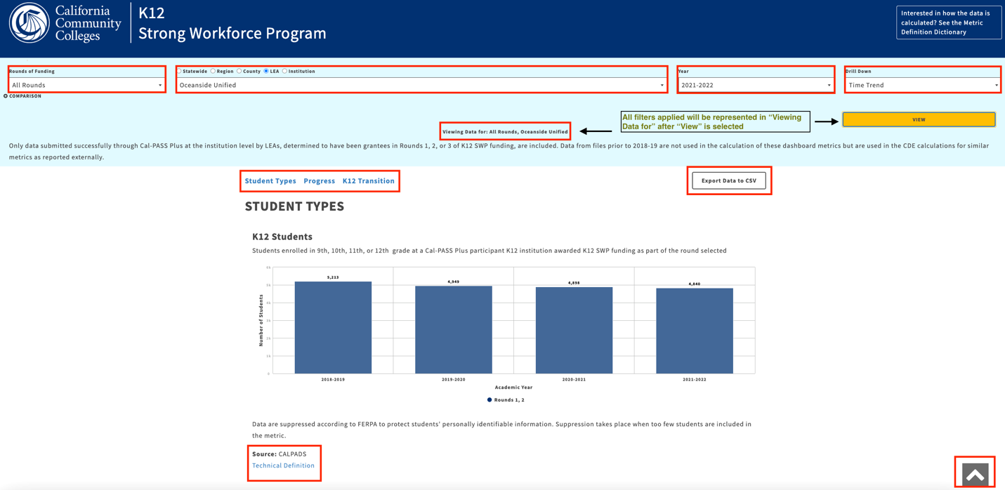
Components:
- The dashboard can be filtered to reflect the view of metrics the user wants to see including Rounds of funding, Locales (statewide, region, county, etc.), Year, and Drill down (time trend, grade levels, demographics, financial aid, etc.)
  - All selections will then be represented in the header section as “Viewing Data for…” once the View button is selected
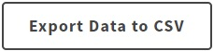
- All data for selections made in the header can be exported to a CSV file by clicking on a button in the upper-right corner near the dropdown selections
- The Metric Definition Dictionary (MDD) is linked in the upper right-hand corner of the header. “Technical Definition” hyperlinks are provided on each graph for quick access to the metric displayed in each graph
  - The MDD highlights data elements, pseudo code, calculations, denominators, and other information to inform users how the metric displayed is defined and calculated. It also provides background and other contextual information about the K12 SWP dashboard.
- Below the header, hyperlinks to sections of the dashboard allow users to quickly access metrics in different stages of the student journey

Metrics Walkthrough: Accessing Counts, Calculating Trends & Analysis
1) Scroll down to K12 students.
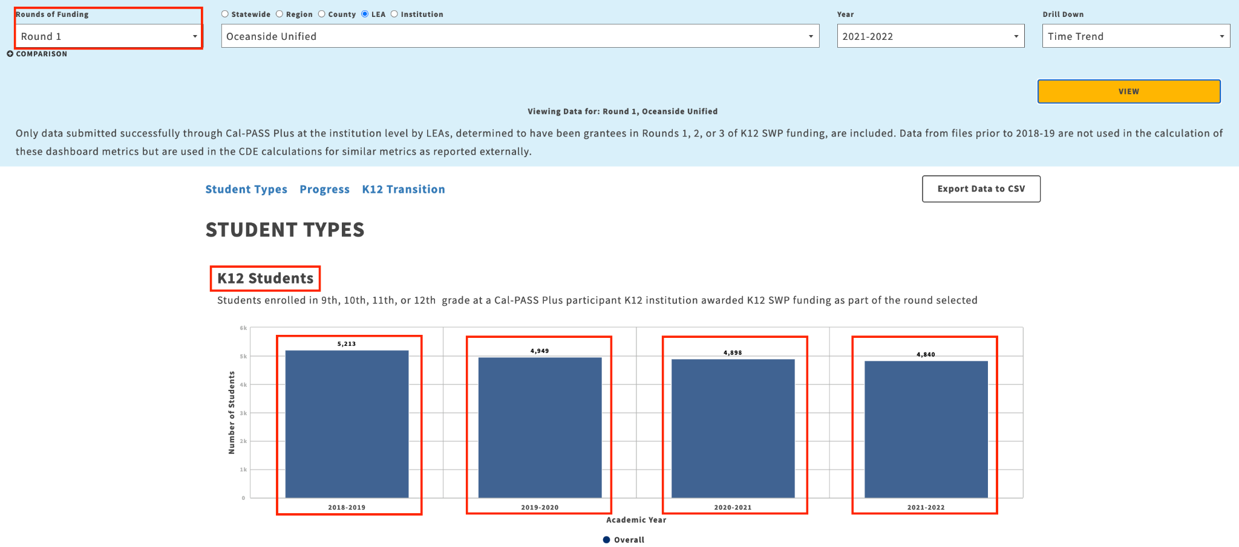
Graph Info: Above the graph, a description is provided under the category title which explains the universe of participant data that is being represented.
Questions: to focus on unduplicated counts of students displayed & calculate trends (Feel free to use the guided questions and tables to input your own data):

- What round of awardees of K12 SWP funding is being displayed?
Rounds 1, 2
- How many K12 students enrolled in 9th-12th grade as part of the round(s) selected?
School Year | No. of K12 students
2018-19 | 5,213
2019-20 | 4,949
2020-21 | 4,898
2021-22 | 4,840

- Calculate the percentage change in K12 students captured by the dashboard between the earliest and latest year available
- 4,840 in 2021-22 - 5,213 in 2018-19 = (373) less K12 students
- (373)/5,213 = -7% decrease in K12 Students in Round 1 for this LEA

2) Scroll down to K12 CTE Completers:
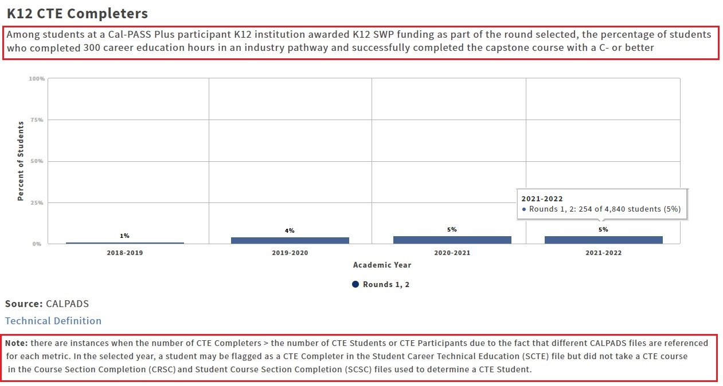
Graph Info: Graphs will display the y-axis metrics in either counts or percentages. When a graph displays percentages (such as K12 CTE Completers) hover over the bar graphs to display both the count or value, denominator and percentage. Notes displayed underneath certain graphs contain important data caveats for the data for the metric.
Questions: to focus on unduplicated counts of students displayed & calculate trends (Feel free to use the guided questions and tables to input your own data):
- What has been the trend for K12 CTE Completers as a count and as a percentage of K12 students?
School Year | No. of K12 CTE Completers | No. of K12 Students | % of K12 CTE Completers
2018-19 | 65 | 5,213 | 1%
2019-20 | 184 | 4,949 | 4%
2020-21 | 255 | 4,898 | 5%
2021-22 | 254 | 4,840 | 5%

- Calculate the percentage change in the number of K12 CTE Completers and in the percentage of K12 CTE Completers between the earliest and latest year available
- 254 in 2021-22 - 65 in 2018-19 = 189 more K12 CTE Completers
- 5% in 2021-22 - 1% in 2018-19 = 4% increase in the percentage of K12 students who are K12 CTE Completers
- Analysis: While there has been a 7% decrease in the number of K12 Students, there has been a 4% increase in the percentage of K12 students who are K12 CTE Completers between school years 2019 and 2022.

Data Equity Lens
The Drill Down menu allows for exploration for Gender, Race, English Learners, etc.

1) Switch the Drill Down in the header to “Gender”, press “View” and scroll down to K12 CTE completers:
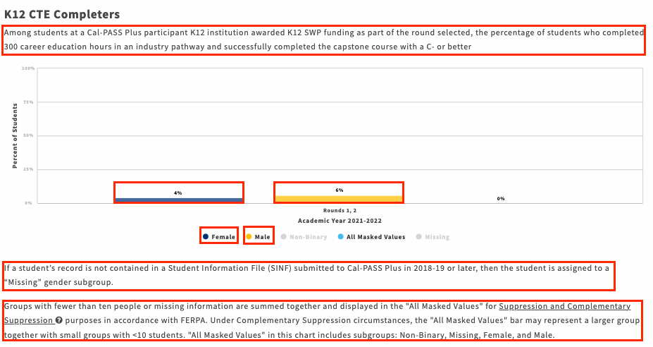
Graph Info: The notes explain why information displayed can be “missing” or not match other CDE displays. Notes also provide information on what subgroups or student populations are masked due to FERPA suppression to protect students’ identities with pop up text to “Suppression and Complementary Suppression” that provides a description of suppression rules for the dashboard. Users will also find text context to All Masked Values which is displayed to represent the subgroups that cannot be shown due to FERPA suppression.
Questions: to focus on unduplicated counts of students displayed & calculate trends (Feel free to use the guided questions and tables to input your own data):
- What year has been selected for display of the drill down information? 2021 - 2022
- What is the number of K12 CTE Completers by gender and what is the % of K12 CTE Completers by gender?
Gender | No. of K12 CTE Completers | No. of K12 Students | % of K12 CTE Completers | School Year
Female | 98 | 2,347 | 4% | 2021-2022
Male | 156 | 2,484 | 6% | 2021-2022
All Masked Values | 0 | 4,840 | 0% | 2021-2022
- Analysis: While there has been a 7% decrease in the number of K12 Students, there has been a 4% increase in the percentage of K12 students who are K12 CTE Completers between school years 2019 and 2022.
Switch the drilldown to “Race/Ethnicity”, press “View” and scroll down to K12 CTE Completers:

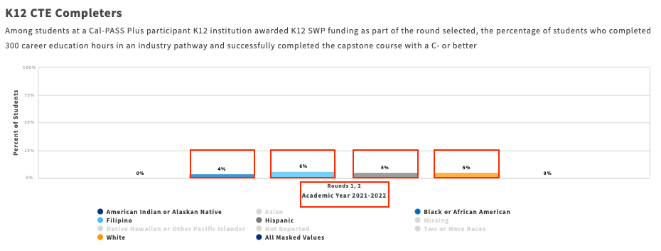
Graph Info: When selecting “Race/Ethnicity” under the drilldown, data snapshots will only represent metrics for the year selected unlike “Time Trend”. This is true for all drilldowns EXCEPT “Time Trend” & “Grade Levels”. In order to compare metrics such as “Race/Ethnicity” by year, users can switch to a comparison view.
Questions: to focus on unduplicated counts of students displayed & calculate trends (Feel free to use the guided questions and tables to input your own data):
- What rounds and year of K12 SWP funding is being displayed?
Rounds 1, 2 2021 - 2022
- What is the count and percentage for K12 CTE completers by Race/Ethnicity?
Race/Ethnicity | No. of K12 CTE Completers | No. of K12 Students | % of K12 CTE Completers | School Year
American Indian or Alaskan Native | 0 | 17 | 0% | 2021-2022
Black or African American | 11 | 246 | 4% | 2021-2022
Filipino | 14 | 226 | 6% | 2021-2022
Hispanic | 152 | 2,884 | 5% | 2021-2022
White | 55 | 1,057 | 5% | 2021-2022
- Calculate the percentage difference by race compared to all K12 CTE completers in 2021-22
- 6% of Filipino K12 CTE completers - 5% for all K12 CTE completers in 21-22 = 1% more K12 CTE Completers who identify as Filipino compared to all students in 2021-2022
- 4% of Black or African American K12 CTE Completers – 5% for all K12 CTE completers in 21-22 = -1% less K12 CTE Completers who identify as Black or African American compared to all students in 2021-2022

- Analysis: There were two groups that had percentages lower than the 5% of all K12 CTE Completers in 2021-2022. “American Indian or Alaskan Native” (0%) was -5% lower and “Black or African American” (4%) was -1% lower. The remaining 3 groups had percentages that either matched or were higher than all K12 CTE Completers in 2021-2022. “Hispanic” (5%) had the same percentage, “White” (5%) had the same percentage, and “Filipino” (6%) was 1% higher than all K12 CTE Completers in 2021-2022. Also note that this table excluded “All Masked Values”.

Comparison View:

Another function built into our dashboard that allows the user to see larger trends across locales is called the comparison view.
Switch the drill down to “gender”. Click on the comparison button, add “Round 1”, “San Diego”, and “2021-2022” then scroll down to K12 CTE Completers:

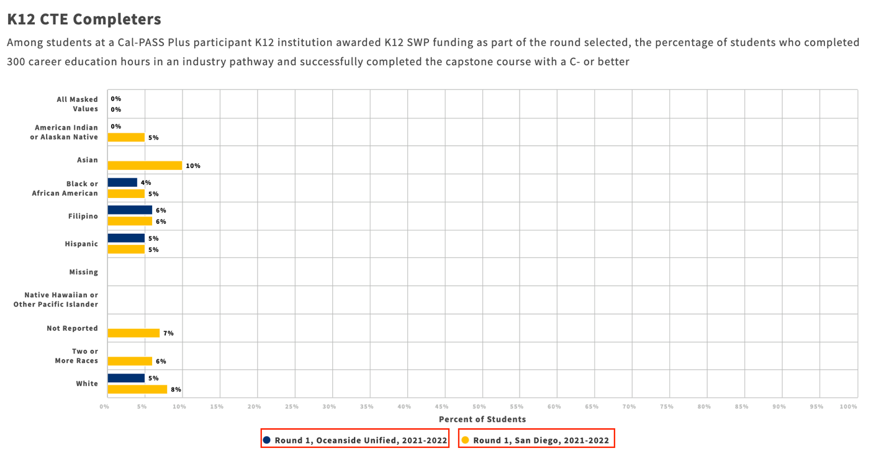

Graph Info: In the comparison view, data in different or the same locale can be presented in one graph. This view allows users to compare disaggregates from one year to another or to compare different locales in a current year.
Questions: to focus on unduplicated counts of students displayed & calculate trends (Feel free to use the guided questions and tables to input your own data):
- What rounds, locales, and year of K12 SWP funding are being compared?
Round 1 Oceanside Unified 2021 - 2022
Round 1 San Diego County 2021 - 2022
- What’s the comparison between K12 CTE completers at the county level vs. at the district level by Race/Ethnicity?
Locale | Race/Ethnicity | No. of K12 CTE Completers | No. of K12 students | % of K12 CTE Completers | School Year
Oceanside | American Indian or Alaskan Native | 0 | 17 | 0% | 2021-2022
San Diego | American Indian or Alaskan Native | 20 | 393 | 5% | 2021-2022
San Diego | Asian | 567 | 5,679 | 10% | 2021-2022
Oceanside | Black or African American | 11 | 246 | 4% | 2021-2022
San Diego | Black or African American | 111 | 2,299 | 5% | 2020-2021
Oceanside | Filipino | 14 | 226 | 6% | 2021-2022
San Diego | Filipino | 310 | 4,988 | 6% | 2021-2022
Oceanside | Hispanic | 152 | 2,884 | 5% | 2021-2022
San Diego | Hispanic | 1,989 | 38,952 | 5% | 2021-2022
San Diego | Two or More Races | 128 | 2,276 | 6% | 2021-2022
Oceanside | White | 55 | 1057 | 5% | 2021-2022
San Diego | White | 2,249 | 28,595 | 8% | 2021-2022

- Calculate the largest percentage differences by race between San Diego and Oceanside K12 CTE Completers in 2021-22.
- 0% of American Indian or Alaskan Native K12 CTE Completers in Oceanside – 5% of American Indian or Alaskan Native K12 CTE Completers in San Diego in 2021-2022 = (5%) less American Indian or Alaskan Native K12 CTE Completers at the district level compared to the county level

- Analysis: San Diego County displays data for groups that were not represented in the Oceanside locale for K12 CTE Completers during 2021-2022. Asian (10%), American Indian or Alaskan Native (5%), and Two or More Races (6%) all met or had higher percentages than all K12 CTE Completers at the Oceanside locale.

