Identifying TOP Codes Assigned to College Programs
Contents
Identifying TOP Codes Assigned to College Programs 1
Which Codes Are Assigned to My Programs? 1
Award codes in Datamart 1
Award Codes in Chancellor’s Office Curriruculum Inventory System (COCI) 4
Course Codes in Datamart 5
Course codes in Chancellor’s Office Curriruculum Inventory System (COCI) 8

Which Codes Are Assigned to My Programs?
Colleges assign Taxonomy of Program (TOP) codes to two types of data records: courses and awards (certificates and degrees). To find out which courses and awards have been assigned to TOP codes at a specific college in the Data Mart and Chancellor’s Office Curriculum Inventory System (COCI), follow these steps.

Award codes in Datamart
- Open your browser to the Chancellor’s Office Data Mart: http://datamart.cccco.edu/datamart.aspx
- Under the top menu, select Queries, and from the submenu, Outcomes.
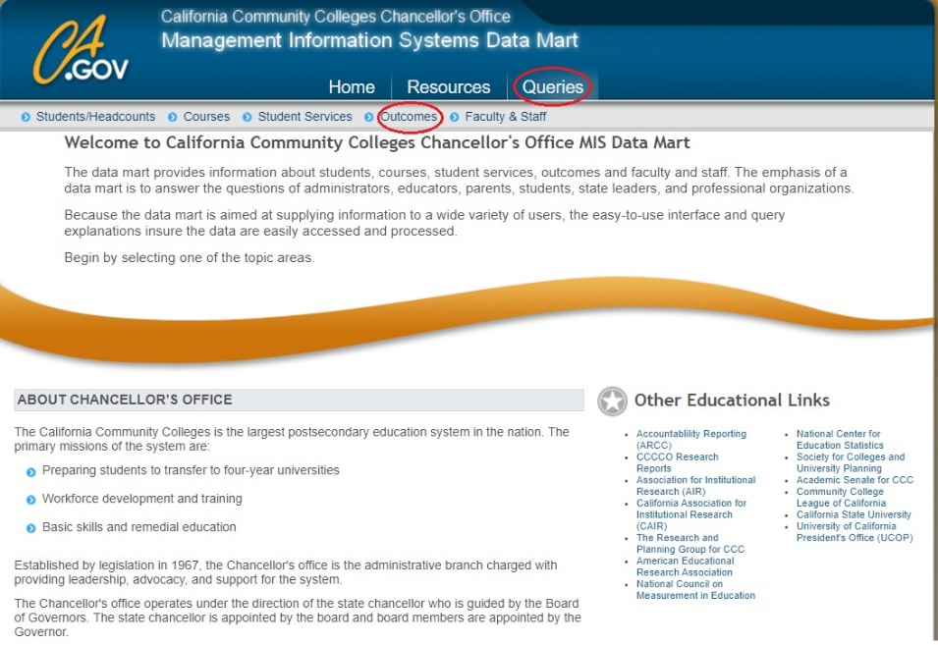
- Under the Outcomes tab, select Program Awards.
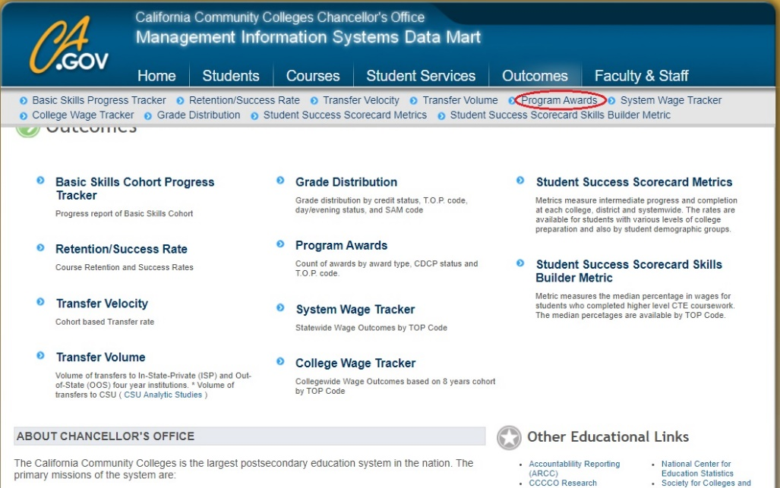
- In the selection menu:
  - Using the Select State‐District‐College option, determine whether you want to view all colleges, all colleges in a district, or specific colleges.
  - If you did not choose the statewide option, use the Select District‐College drop down menu to pick the related institution(s).
  - Use the Select Academic Year to determine which dates to include.
  - From the Select Award Type menu, determine which types of certificates and degrees to include.
  - EITHER use the Select Program Type menu to pick the specific TOP code you want to see (choose at the TOP 2, TOP 4, or TOP 6 level by clicking on the plus signs to the left of each code to reveal nested codes).
  - Hit the View Report button.
  - You can now see all awards included under the TOP code selected.
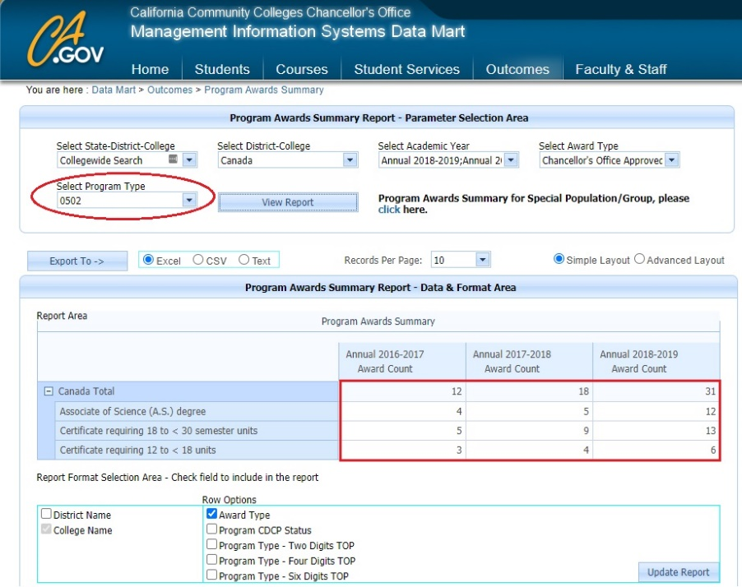
  - OR select “All Programs” in the Select Program Type drop down and hit View Report button.
  - At the bottom, select Program Type – Six Digits TOP or Four Digits TOP or Two Digits TOP to see all awards on all TOP codes by award type.
  - Make sure to click on Update Report button to see your selection
  - You can now see all awards and all TOP codes on which awards are offered.
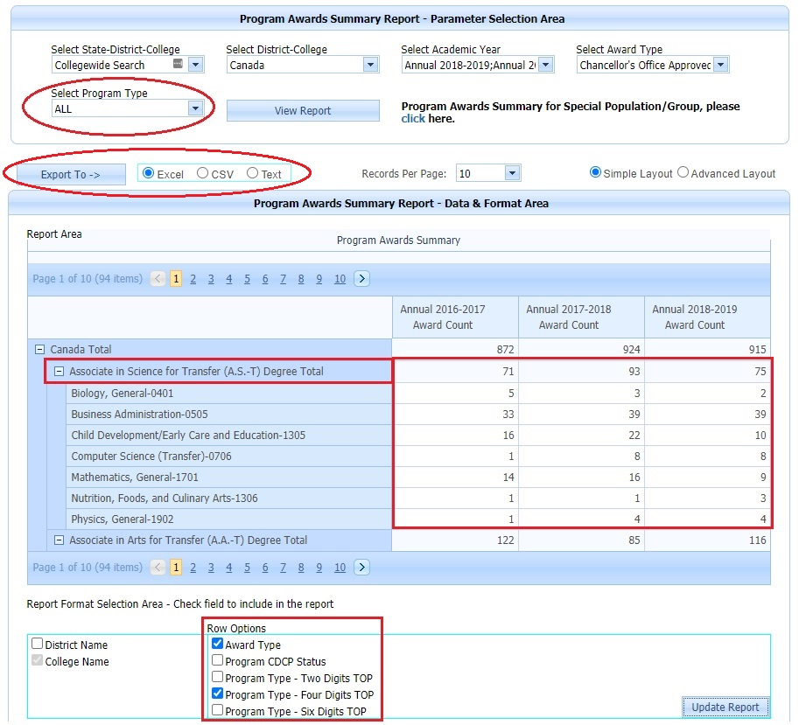
  - Either all awards on a selected TOP code or all awards on all TOP codes can be exported to Excel or csv for the institution(s) and academic year(s) selected
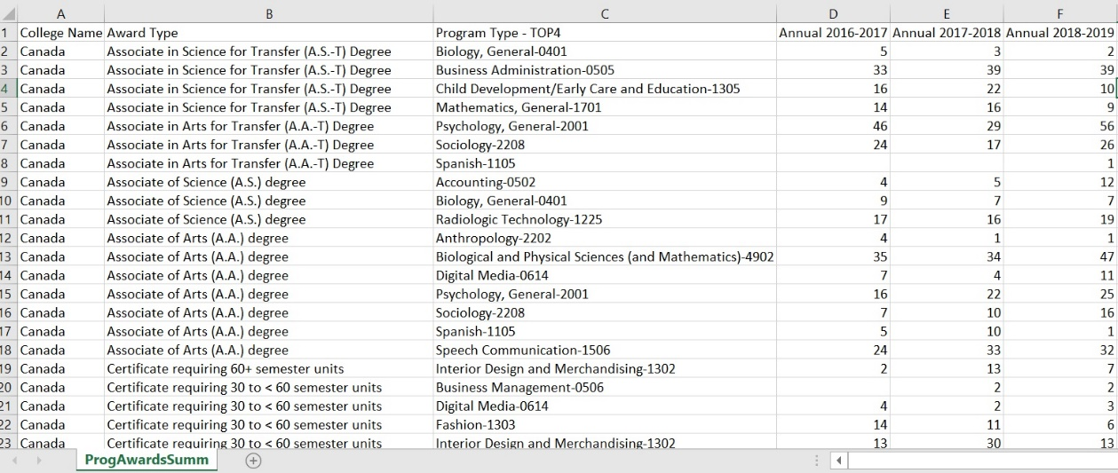

Award Codes in Chancellor’s Office Curriruculum Inventory System (COCI)
- Open your browser to COCI: https://coci2.ccctechcenter.org/programs
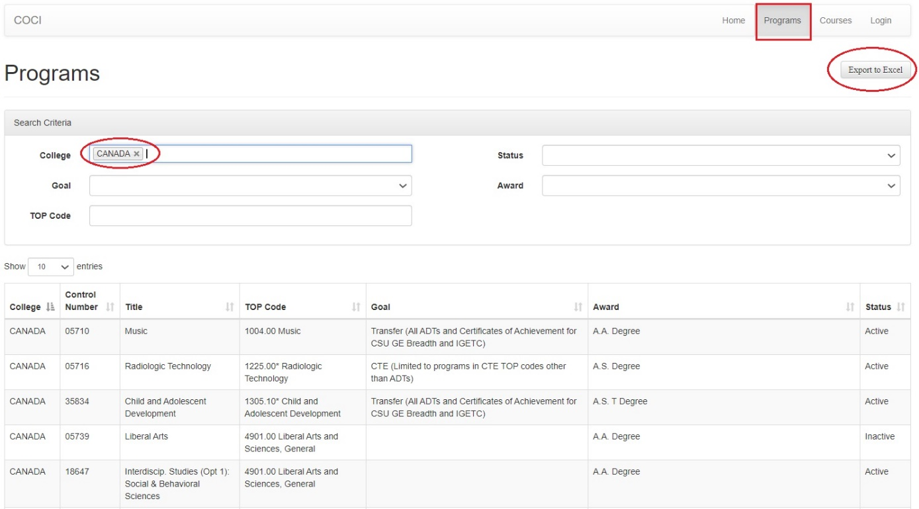
- Select your Programs at the top and college and export to Excel
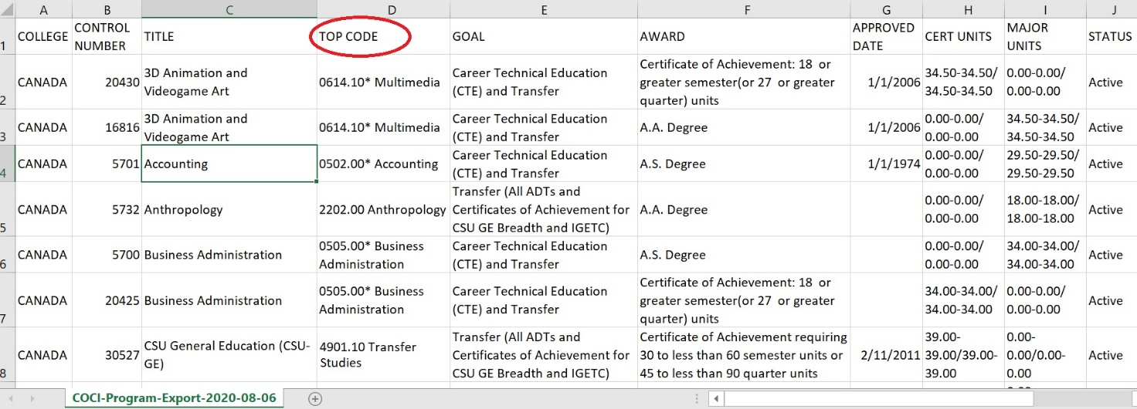

Course Codes in Datamart
- Open your browser to the Chancellor’s Office Data Mart: http://datamart.cccco.edu/datamart.aspx
- Under the top menu, select Queries, and from the submenu, Courses.
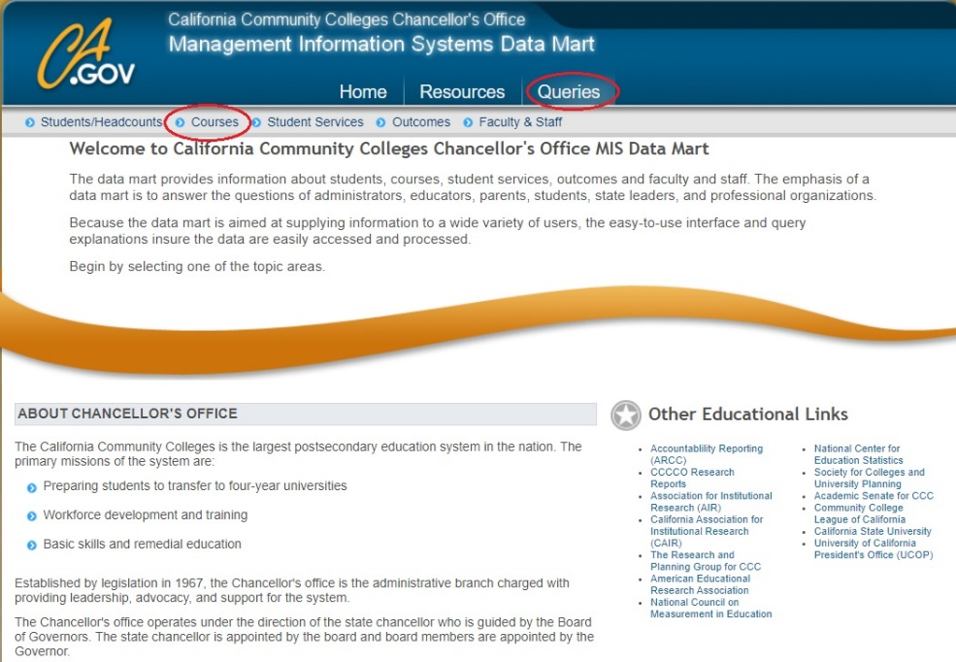
- Select Course Details
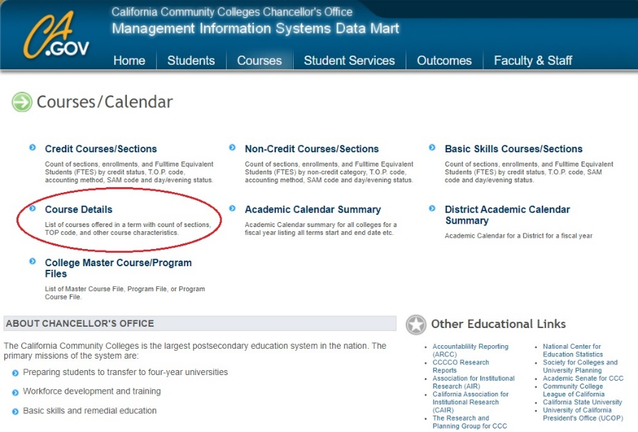
  - Using the Select State‐District‐College option, determine whether you want to view all colleges, all colleges in a district, or specific colleges.
  - If you did not choose the statewide option, use the Select District‐College drop down menu to pick the related institution(s).
  - Use the Select Term to determine which dates to include.
  - Use the Select TOP code menu to pick the specific TOP code you want to see (choose at the TOP 2, TOP 4, or TOP 6 level by clicking on the plus signs to the left of each code to reveal nested codes) OR select “All” to see all six-digit TOP codes
  - Hit the View Report button.
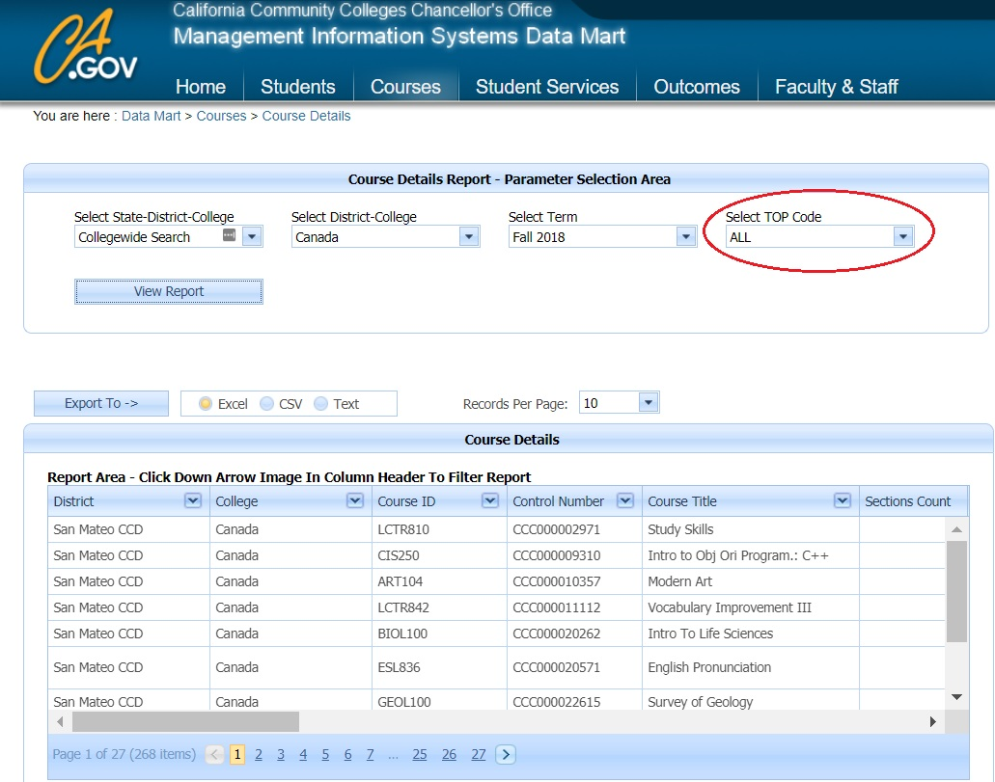
  - Scroll to the right on the navigation bar to see which TOP codes are assigned to courses
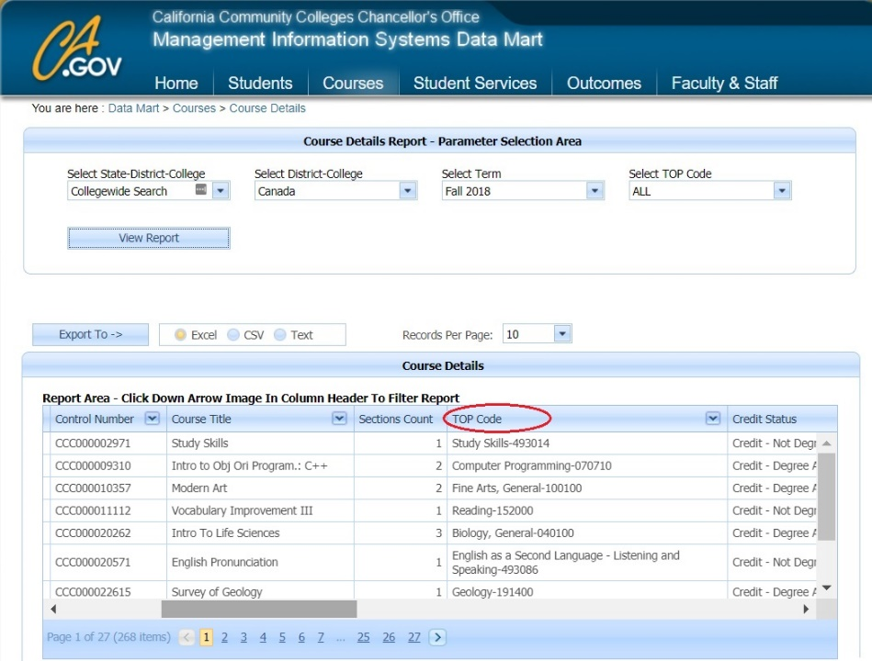
  - Export to excel or csv
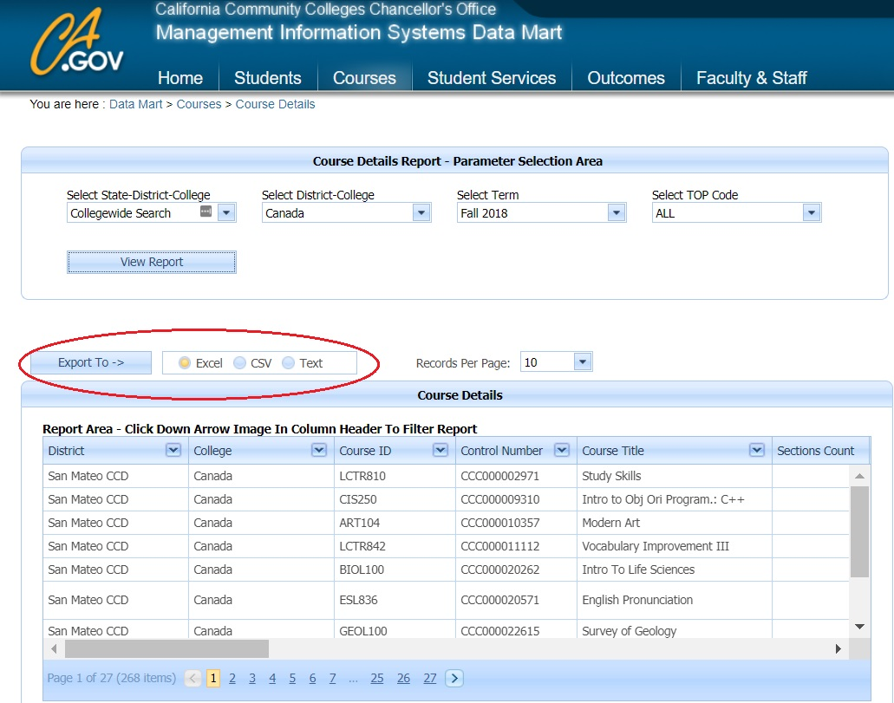
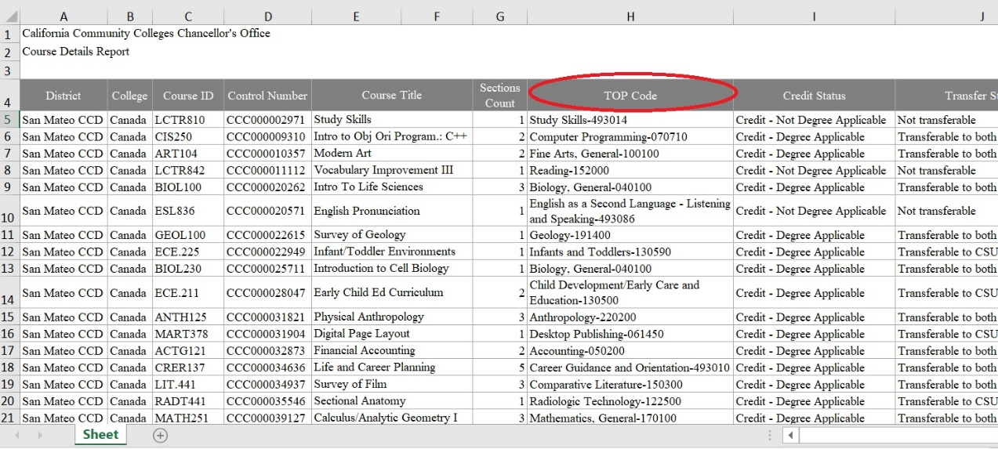

Course codes in Chancellor’s Office Curriruculum Inventory System (COCI)
- Open your browser to COCI: https://coci2.ccctechcenter.org/programs
- Select your Programs at the top and college and export to Excel
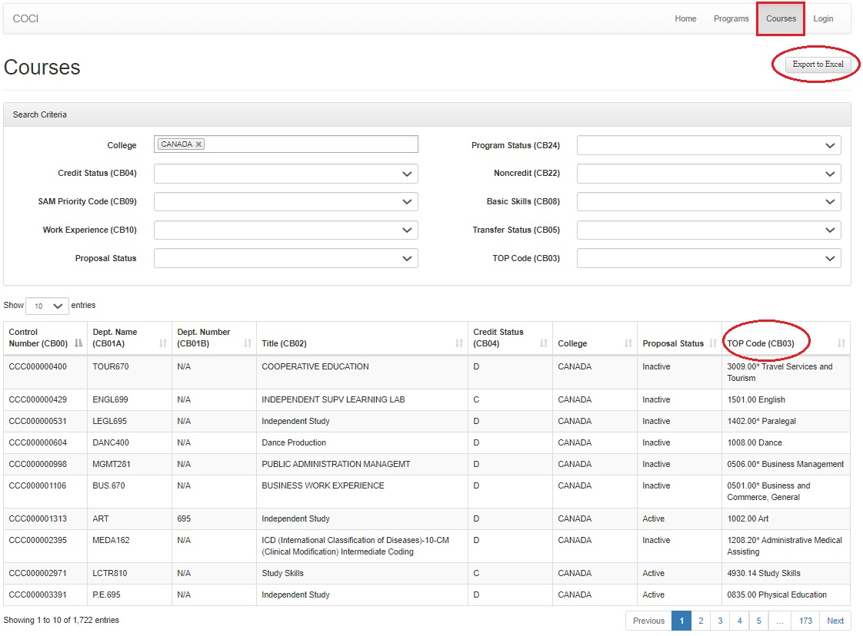
- Select your college and export to Excel
