Are Students Getting Employed in Their Field of Study?
Updated March 2021
There are two primary metrics to indicate whether or not students are employed in their field of study: percentage in a job closely related to field of study and top five industries of employment. Both of these metrics can be found on the LaunchBoard Community College Pipeline under the Employment tab. This information is displayed in easy‐to‐read charts and data tables and can be viewed by college, district, region, or statewide. Users can select program information by the Taxonomy of Program 6-digit code (TOP6) level, Taxonomy of Program 4-digit level (TOP4), industry sector or occupational cluster, all‐Career Technical Education (CTE) or non‐CTE, and all program levels. Looking at both metrics may help ascertain if the skills taught in a program lead to employment in a related field.

Percentage in a Job Closely Related to Field of Study
The most well‐known metric on employment in a related field, which is incorporated into the Chancellor’s Office Vision for Success and the Strong Workforce Program, comes from a question on the CTE Outcomes Survey. Students self‐report whether they are employed in the same or similar field as their program of study. The metric is included in three LaunchBoard dashboards: Student Success Metrics, Strong Workforce Program and Community College Pipeline. The latest data available from the Student Success Metrics shows that 13,175 out of 18,615 students or 71% of CTE students who responded to the question reported working in a job related to their field of study in 2017-18.
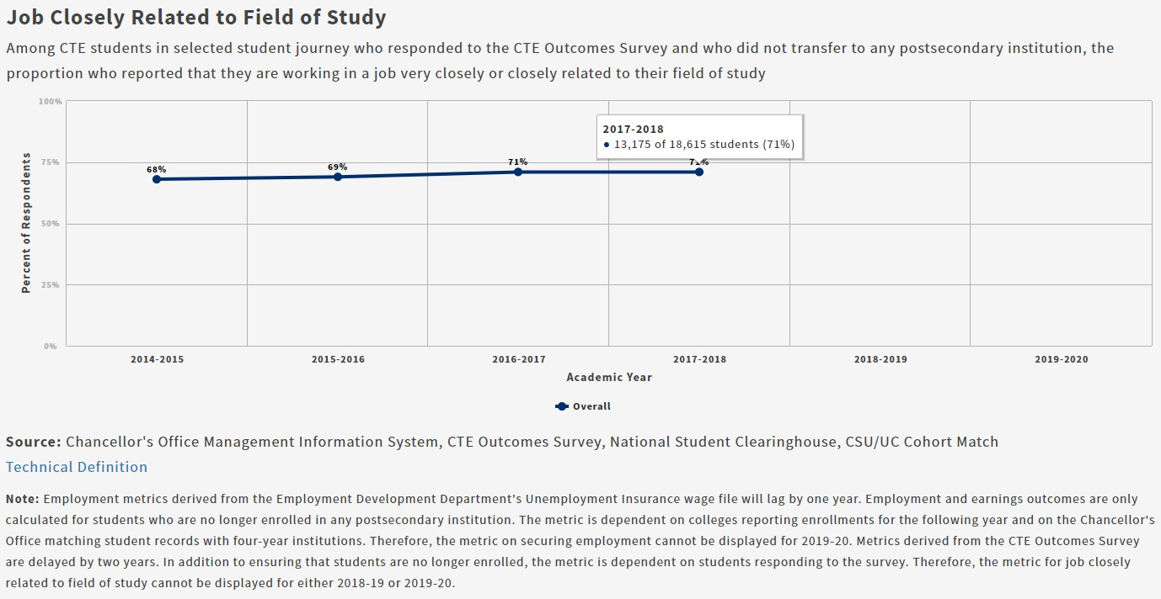
Table 1

Survey data is useful because it allows for students to evaluate whether they are applying the skills that they learned in college. However, it does have some limitations. The CTE Outcomes Survey is only sent to career education students that have graduated or taken at least nine units, and responses represent only a subset of all exiting students, which means that results may be based on a small number of people especially at the sector or TOP code level.
For more information on the CTEOS, visit the Santa Rosa Junior College CTE Outcomes Survey website.

Top Five Industries of Employment
Another LaunchBoard metric identifies the top five industry sectors in which students are working as defined by the North American Industry Classification System (NAICS) code. Industry sectors reflect groupings of similar types of employers, such as construction or retail. NAICS code information comes from the Chancellor’s Office match with the California Unemployment Insurance (UI) Wage File, the same source used for other employment and earnings metrics.
NAICS codes are based on the activity that generates the majority of a business’ revenue. These codes are self‐assigned by employers and are usually provided on administrative, survey, or census reports collected by the government. Information from the UI file is only available for students who have exited all postsecondary institutions with valid social security numbers and is not used in the Vision for Success goal regarding students who are employed in their field of study. The UI wage match does not capture students who are self-employed, working in the cash economy, employed outside of California, employed by the Federal government or in the military. However, about 75-80% of exiting students are matched.
This metric is especially useful to consider if a program’s related occupations align with a specific industry sector or a limited number of sectors. For example, if a program trains medical assistants, then NAICS codes should include health‐related sectors. However, if a program trains business information workers, then students could work in many different industry settings including both construction and retail.
When a company reports earnings for a worker as part of the UI wage data to the state, that individual is considered to be employed in the sector without consideration of the occupation. If the student is a business information worker at a company with a utilities NAICS code, then that person is considered to be working in the utilities sector. A student could also graduate with an associate degree in telecommunications technology, get a job as an office clerk (not using skills acquired as part of the degree) and still be counted as working in the utilities sector.
Another complicating factor when considering NAICS codes is that some industry sectors may rely heavily on hiring workers through temporary agencies. Students hired through these types of third party employment agencies will be counted as working in code 5613 Employment Services (see table below) even though they may actually be working in a completely different sector like construction.
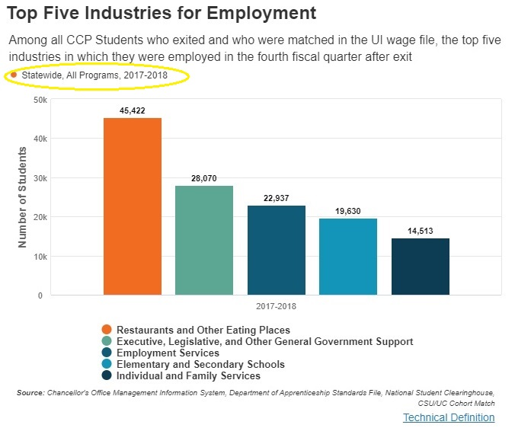
Table 1
The top five industry sectors when “All Programs” is selected on the Community College Pipeline for Statewide in 2017-18 include:
- Restaurants and Other Eating Places (7225)
- Executive, Legislative, and Other General Government Support (9211)
- Employment Services (5613)
- Elementary and Secondary Schools (6111)
- Individual and Family Services (6241)
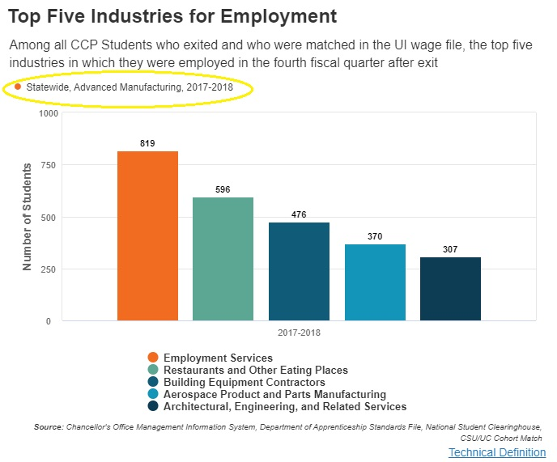
Table 2
The top five industry sectors when “Advanced Manufacturing” is selected on the Community College Pipeline for Statewide in 2017-18 include:
- Employment Services (5613)
- Restaurants and Other Eating Places (7225)
- Building Equipment Contractors (2382)
- Aerospace Product and Parts Manufacturing (3364)
- Architectural, Engineering and Related Services (5413)
At the “All Programs” or “All CTE Programs” level, it is not entirely clear if students are employed in their field of study or related industry sector(s). However, if sectors or programs are selected, it becomes clearer whether or not students are getting employed in their field or related industry sector(s) as evident in the top five NAICS codes displayed for the Advanced Manufacturing sector. Sometimes, the titles of the four-digit NAICS codes displayed are not always clear. For NAICS code definitions at any level, go the Census Bureau website for the 2017 NAICS definitions document.

NAICS Codes
Just like TOP codes which can be expressed at the two, four and six-digit levels, NAICS codes can be expressed at different levels including two, three, four, five and six-digit. Beginning with the 2018-19 build of the Community College Pipeline, the top five industries for employment are expressed at the four-digit level. Please see table below for the 2017 US NAICS codes and titles for four-digit codes.
For more information on NAICS codes including descriptions, please refer to the Census Bureau website at https://www.census.gov/naics/ including downloadable versions and NAICS code definitions.

4-Digit Code | 2017 NAICS US Title
1111 | Oilseed and Grain Farming
1112 | Vegetable and Melon Farming
1113 | Fruit and Tree Nut Farming
1114 | Greenhouse, Nursery, and Floriculture Production
1119 | Other Crop Farming
1121 | Cattle Ranching and Farming
1122 | Hog and Pig Farming
1123 | Poultry and Egg Production
1124 | Sheep and Goat Farming
1125 | Aquaculture
1129 | Other Animal Production
1131 | Timber Tract Operations
1132 | Forest Nurseries and Gathering of Forest Products
1133 | Logging
1141 | Fishing
1142 | Hunting and Trapping
1151 | Support Activities for Crop Production
1152 | Support Activities for Animal Production
1153 | Support Activities for Forestry
2111 | Oil and Gas Extraction
2121 | Coal Mining
2122 | Metal Ore Mining
2123 | Nonmetallic Mineral Mining and Quarrying
2131 | Support Activities for Mining
2211 | Electric Power Generation, Transmission and Distribution
2212 | Natural Gas Distribution
2213 | Water, Sewage and Other Systems
2361 | Residential Building Construction
2362 | Nonresidential Building Construction
2371 | Utility System Construction
2372 | Land Subdivision
2373 | Highway, Street, and Bridge Construction
2379 | Other Heavy and Civil Engineering Construction
2381 | Foundation, Structure, and Building Exterior Contractors
2382 | Building Equipment Contractors
2383 | Building Finishing Contractors
2389 | Other Specialty Trade Contractors
3111 | Animal Food Manufacturing
3112 | Grain and Oilseed Milling
3113 | Sugar and Confectionery Product Manufacturing
3114 | Fruit and Vegetable Preserving and Specialty Food Manufacturing
3115 | Dairy Product Manufacturing
3116 | Animal Slaughtering and Processing
3117 | Seafood Product Preparation and Packaging
3118 | Bakeries and Tortilla Manufacturing
3119 | Other Food Manufacturing
3121 | Beverage Manufacturing
3122 | Tobacco Manufacturing
3131 | Fiber, Yarn, and Thread Mills
3132 | Fabric Mills
3133 | Textile and Fabric Finishing and Fabric Coating Mills
3141 | Textile Furnishings Mills
3149 | Other Textile Product Mills
3151 | Apparel Knitting Mills
3152 | Cut and Sew Apparel Manufacturing
3159 | Apparel Accessories and Other Apparel Manufacturing
3161 | Leather and Hide Tanning and Finishing
3162 | Footwear Manufacturing
3169 | Other Leather and Allied Product Manufacturing
3211 | Sawmills and Wood Preservation
3212 | Veneer, Plywood, and Engineered Wood Product Manufacturing
3219 | Other Wood Product Manufacturing
3221 | Pulp, Paper, and Paperboard Mills
3222 | Converted Paper Product Manufacturing
3231 | Printing and Related Support Activities
3241 | Petroleum and Coal Products Manufacturing
3251 | Basic Chemical Manufacturing
3252 | Resin, Synthetic Rubber, and Artificial and Synthetic Fibers and Filaments Manufacturing
3253 | Pesticide, Fertilizer, and Other Agricultural Chemical Manufacturing
3254 | Pharmaceutical and Medicine Manufacturing
3255 | Paint, Coating, and Adhesive Manufacturing
3256 | Soap, Cleaning Compound, and Toilet Preparation Manufacturing
3259 | Other Chemical Product and Preparation Manufacturing
3261 | Plastics Product Manufacturing
3262 | Rubber Product Manufacturing
3271 | Clay Product and Refractory Manufacturing
3272 | Glass and Glass Product Manufacturing
3273 | Cement and Concrete Product Manufacturing
3274 | Lime and Gypsum Product Manufacturing
3279 | Other Nonmetallic Mineral Product Manufacturing
3311 | Iron and Steel Mills and Ferroalloy Manufacturing
3312 | Steel Product Manufacturing from Purchased Steel
3313 | Alumina and Aluminum Production and Processing
3314 | Nonferrous Metal (except Aluminum) Production and Processing
3315 | Foundries
3321 | Forging and Stamping
3322 | Cutlery and Handtool Manufacturing
3323 | Architectural and Structural Metals Manufacturing
3324 | Boiler, Tank, and Shipping Container Manufacturing
3325 | Hardware Manufacturing
3326 | Spring and Wire Product Manufacturing
3327 | Machine Shops; Turned Product; and Screw, Nut, and Bolt Manufacturing
3328 | Coating, Engraving, Heat Treating, and Allied Activities
3329 | Other Fabricated Metal Product Manufacturing
3331 | Agriculture, Construction, and Mining Machinery Manufacturing
3332 | Industrial Machinery Manufacturing
3333 | Commercial and Service Industry Machinery Manufacturing
3334 | Ventilation, Heating, Air-Conditioning, and Commercial Refrigeration Equipment Manufacturing
3335 | Metalworking Machinery Manufacturing
3336 | Engine, Turbine, and Power Transmission Equipment Manufacturing
3339 | Other General Purpose Machinery Manufacturing
3341 | Computer and Peripheral Equipment Manufacturing
3342 | Communications Equipment Manufacturing
3343 | Audio and Video Equipment Manufacturing
3344 | Semiconductor and Other Electronic Component Manufacturing
3345 | Navigational, Measuring, Electromedical, and Control Instruments Manufacturing
3346 | Manufacturing and Reproducing Magnetic and Optical Media
3351 | Electric Lighting Equipment Manufacturing
3352 | Household Appliance Manufacturing
3353 | Electrical Equipment Manufacturing
3359 | Other Electrical Equipment and Component Manufacturing
3361 | Motor Vehicle Manufacturing
3362 | Motor Vehicle Body and Trailer Manufacturing
3363 | Motor Vehicle Parts Manufacturing
3364 | Aerospace Product and Parts Manufacturing
3365 | Railroad Rolling Stock Manufacturing
3366 | Ship and Boat Building
3369 | Other Transportation Equipment Manufacturing
3371 | Household and Institutional Furniture and Kitchen Cabinet Manufacturing
3372 | Office Furniture (including Fixtures) Manufacturing
3379 | Other Furniture Related Product Manufacturing
3391 | Medical Equipment and Supplies Manufacturing
3399 | Other Miscellaneous Manufacturing
4231 | Motor Vehicle and Motor Vehicle Parts and Supplies Merchant Wholesalers
4232 | Furniture and Home Furnishing Merchant Wholesalers
4233 | Lumber and Other Construction Materials Merchant Wholesalers
4234 | Professional and Commercial Equipment and Supplies Merchant Wholesalers
4235 | Metal and Mineral (except Petroleum) Merchant Wholesalers
4236 | Household Appliances and Electrical and Electronic Goods Merchant Wholesalers
4237 | Hardware, and Plumbing and Heating Equipment and Supplies Merchant Wholesalers
4238 | Machinery, Equipment, and Supplies Merchant Wholesalers
4239 | Miscellaneous Durable Goods Merchant Wholesalers
4241 | Paper and Paper Product Merchant Wholesalers
4242 | Drugs and Druggists' Sundries Merchant Wholesalers
4243 | Apparel, Piece Goods, and Notions Merchant Wholesalers
4244 | Grocery and Related Product Merchant Wholesalers
4245 | Farm Product Raw Material Merchant Wholesalers
4246 | Chemical and Allied Products Merchant Wholesalers
4247 | Petroleum and Petroleum Products Merchant Wholesalers
4248 | Beer, Wine, and Distilled Alcoholic Beverage Merchant Wholesalers
4249 | Miscellaneous Nondurable Goods Merchant Wholesalers
4251 | Wholesale Electronic Markets and Agents and Brokers
4411 | Automobile Dealers
4412 | Other Motor Vehicle Dealers
4413 | Automotive Parts, Accessories, and Tire Stores
4421 | Furniture Stores
4422 | Home Furnishings Stores
4431 | Electronics and Appliance Stores
4441 | Building Material and Supplies Dealers
4442 | Lawn and Garden Equipment and Supplies Stores
4451 | Grocery Stores
4452 | Specialty Food Stores
4453 | Beer, Wine, and Liquor Stores
4461 | Health and Personal Care Stores
4471 | Gasoline Stations
4481 | Clothing Stores
4482 | Shoe Stores
4483 | Jewelry, Luggage, and Leather Goods Stores
4511 | Sporting Goods, Hobby, and Musical Instrument Stores
4512 | Book Stores and News Dealers
4522 | Department Stores
4523 | General Merchandise Stores, including Warehouse Clubs and Supercenters
4531 | Florists
4532 | Office Supplies, Stationery, and Gift Stores
4533 | Used Merchandise Stores
4539 | Other Miscellaneous Store Retailers
4541 | Electronic Shopping and Mail-Order Houses
4542 | Vending Machine Operators
4543 | Direct Selling Establishments
4811 | Scheduled Air Transportation
4812 | Nonscheduled Air Transportation
4821 | Rail Transportation
4831 | Deep Sea, Coastal, and Great Lakes Water Transportation
4832 | Inland Water Transportation
4841 | General Freight Trucking
4842 | Specialized Freight Trucking
4851 | Urban Transit Systems
4852 | Interurban and Rural Bus Transportation
4853 | Taxi and Limousine Service
4854 | School and Employee Bus Transportation
4855 | Charter Bus Industry
4859 | Other Transit and Ground Passenger Transportation
4861 | Pipeline Transportation of Crude Oil
4862 | Pipeline Transportation of Natural Gas
4869 | Other Pipeline Transportation
4871 | Scenic and Sightseeing Transportation, Land
4872 | Scenic and Sightseeing Transportation, Water
4879 | Scenic and Sightseeing Transportation, Other
4881 | Support Activities for Air Transportation
4882 | Support Activities for Rail Transportation
4883 | Support Activities for Water Transportation
4884 | Support Activities for Road Transportation
4885 | Freight Transportation Arrangement
4889 | Other Support Activities for Transportation
4911 | Postal Service
4921 | Couriers and Express Delivery Services
4922 | Local Messengers and Local Delivery
4931 | Warehousing and Storage
5111 | Newspaper, Periodical, Book, and Directory Publishers
5112 | Software Publishers
5121 | Motion Picture and Video Industries
5122 | Sound Recording Industries
5151 | Radio and Television Broadcasting
5152 | Cable and Other Subscription Programming
5173 | Wired and Wireless Telecommunications Carriers
5174 | Satellite Telecommunications
5179 | Other Telecommunications
5182 | Data Processing, Hosting, and Related Services
5191 | Other Information Services
5211 | Monetary Authorities-Central Bank
5221 | Depository Credit Intermediation
5222 | Nondepository Credit Intermediation
5223 | Activities Related to Credit Intermediation
5231 | Securities and Commodity Contracts Intermediation and Brokerage
5232 | Securities and Commodity Exchanges
5239 | Other Financial Investment Activities
5241 | Insurance Carriers
5242 | Agencies, Brokerages, and Other Insurance Related Activities
5251 | Insurance and Employee Benefit Funds
5259 | Other Investment Pools and Funds
5311 | Lessors of Real Estate
5312 | Offices of Real Estate Agents and Brokers
5313 | Activities Related to Real Estate
5321 | Automotive Equipment Rental and Leasing
5322 | Consumer Goods Rental
5323 | General Rental Centers
5324 | Commercial and Industrial Machinery and Equipment Rental and Leasing
5331 | Lessors of Nonfinancial Intangible Assets (except Copyrighted Works)
5411 | Legal Services
5412 | Accounting, Tax Preparation, Bookkeeping, and Payroll Services
5413 | Architectural, Engineering, and Related Services
5414 | Specialized Design Services
5415 | Computer Systems Design and Related Services
5416 | Management, Scientific, and Technical Consulting Services
5417 | Scientific Research and Development Services
5418 | Advertising, Public Relations, and Related Services
5419 | Other Professional, Scientific, and Technical Services
5511 | Management of Companies and Enterprises
5611 | Office Administrative Services
5612 | Facilities Support Services
5613 | Employment Services
5614 | Business Support Services
5615 | Travel Arrangement and Reservation Services
5616 | Investigation and Security Services
5617 | Services to Buildings and Dwellings
5619 | Other Support Services
5621 | Waste Collection
5622 | Waste Treatment and Disposal
5629 | Remediation and Other Waste Management Services
6111 | Elementary and Secondary Schools
6112 | Junior Colleges
6113 | Colleges, Universities, and Professional Schools
6114 | Business Schools and Computer and Management Training
6115 | Technical and Trade Schools
6116 | Other Schools and Instruction
6117 | Educational Support Services
6211 | Offices of Physicians
6212 | Offices of Dentists
6213 | Offices of Other Health Practitioners
6214 | Outpatient Care Centers
6215 | Medical and Diagnostic Laboratories
6216 | Home Health Care Services
6219 | Other Ambulatory Health Care Services
6221 | General Medical and Surgical Hospitals
6222 | Psychiatric and Substance Abuse Hospitals
6223 | Specialty (except Psychiatric and Substance Abuse) Hospitals
6231 | Nursing Care Facilities (Skilled Nursing Facilities)
6232 | Residential Intellectual and Developmental Disability, Mental Health, and Substance Abuse Facilities
6233 | Continuing Care Retirement Communities and Assisted Living Facilities for the Elderly
6239 | Other Residential Care Facilities
6241 | Individual and Family Services
6242 | Community Food and Housing, and Emergency and Other Relief Services
6243 | Vocational Rehabilitation Services
6244 | Child Day Care Services
7111 | Performing Arts Companies
7112 | Spectator Sports
7113 | Promoters of Performing Arts, Sports, and Similar Events
7114 | Agents and Managers for Artists, Athletes, Entertainers, and Other Public Figures
7115 | Independent Artists, Writers, and Performers
7121 | Museums, Historical Sites, and Similar Institutions
7131 | Amusement Parks and Arcades
7132 | Gambling Industries
7139 | Other Amusement and Recreation Industries
7211 | Traveler Accommodation
7212 | RV (Recreational Vehicle) Parks and Recreational Camps
7213 | Rooming and Boarding Houses, Dormitories, and Workers' Camps
7223 | Special Food Services
7224 | Drinking Places (Alcoholic Beverages)
7225 | Restaurants and Other Eating Places
8111 | Automotive Repair and Maintenance
8112 | Electronic and Precision Equipment Repair and Maintenance
8113 | Commercial and Industrial Machinery and Equipment (except Automotive and Electronic) Repair and Maintenance
8114 | Personal and Household Goods Repair and Maintenance
8121 | Personal Care Services
8122 | Death Care Services
8123 | Drycleaning and Laundry Services
8129 | Other Personal Services
8131 | Religious Organizations
8132 | Grantmaking and Giving Services
8133 | Social Advocacy Organizations
8134 | Civic and Social Organizations
8139 | Business, Professional, Labor, Political, and Similar Organizations
8141 | Private Households
9211 | Executive, Legislative, and Other General Government Support
9221 | Justice, Public Order, and Safety Activities
9231 | Administration of Human Resource Programs
9241 | Administration of Environmental Quality Programs
9251 | Administration of Housing Programs, Urban Planning, and Community Development
9261 | Administration of Economic Programs
9271 | Space Research and Technology
9281 | National Security and International Affairs

